**Flight Booking System**

**Database Management Systems**

Tables ER Diagram:

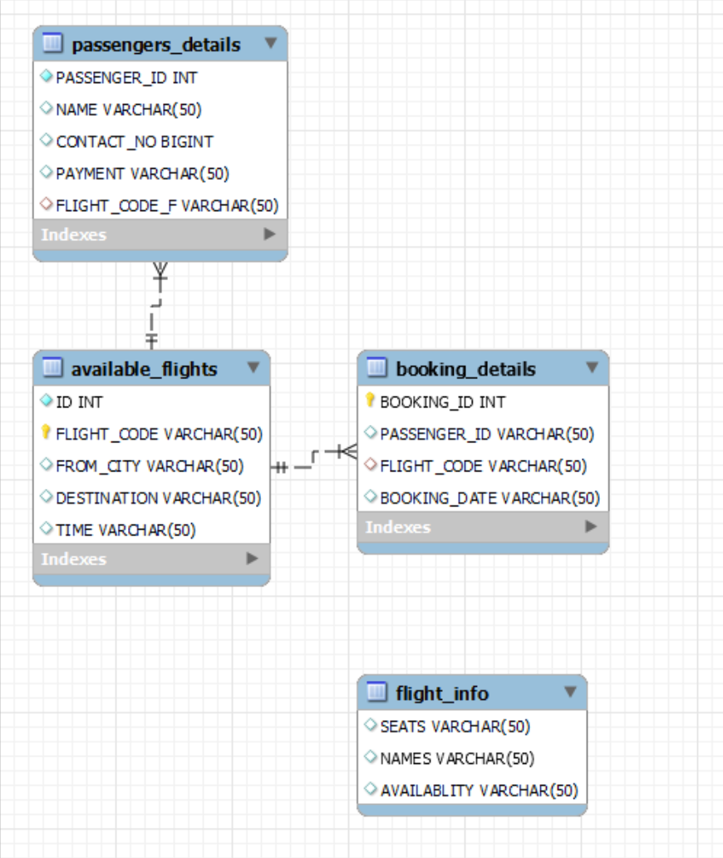

**passengers_details Table data**

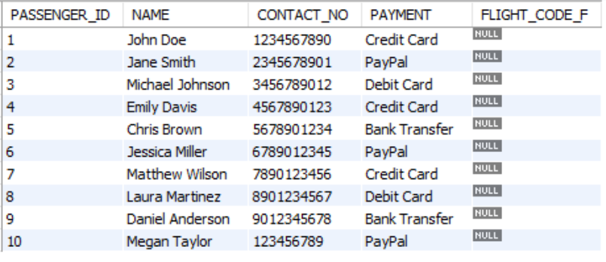

**available_flights Table data**

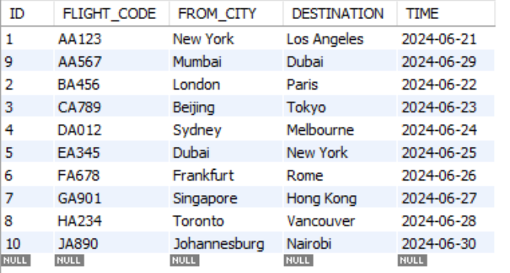

**flight_info Table data**

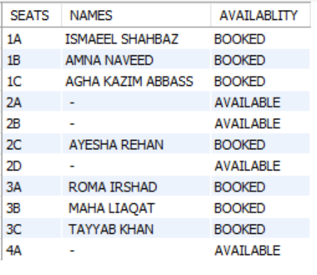

**Booking_details Table data**

